Logging Application

Design

UML Activity Diagrams
Application – Log events
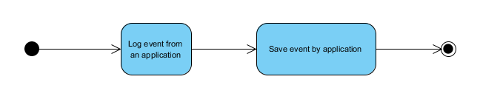
User – Log Search process
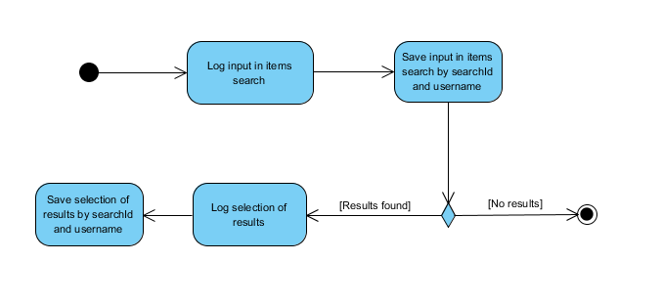
User – Log checkout process
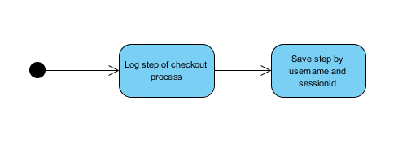

Architecture - Logic View

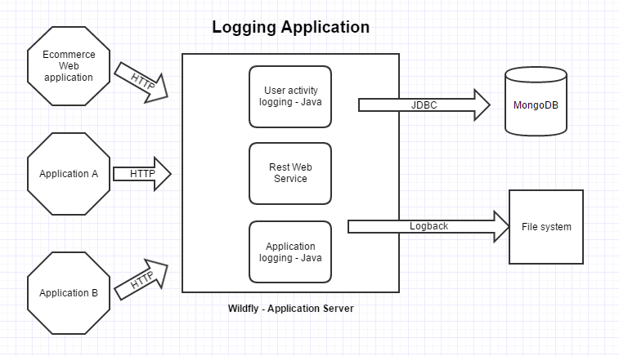

Architecture – Technical details
According to the diagram above the Logging application has three modules:
- User activity logging
A Java application (JAR file) that will connect to a Mongo database via JDBC and will store all activity a user does in e-commerce website. This information will be received by this module from Rest Web service application.
- Application activity logging
A Java application (JAR file) that will store log data into a specific file. It uses Logback as logging framework. This information will be received by this module from Rest Web service application.
- Rest web service application
A JEE application (WAR file) that will receive requests from a REST client. This application can be deployed in any web server or application server. It is using Resteasy as rest framework.
The two applications above are included as libraries inside this application to a right deploy in any web container.

Development tools
Eclipse is used as IDE and the three applications can be built using maven. Every pom file (maven) has everything necessary to build every file.
Logback is used as logging framework in application logging application
Resteasy is used as rest web services framework in rest web service application
Wildfly is used as application server. But any other tool of same type can be used to deploy WAR application.
Maven is used as build tool and dependency management tool during development phase.
Every developed application is compiled in JDK8. So JDK 8 or later is a prerequisite to develop and deploy the whole application.
Junit is used in a single test in Application Logging Activity application. Optional tool this one.

Application logging considerations
About Quick Search functionality, Apache commons or BufferedReader class can be used to search through log. More complicated could be using grep, sed and awk commands from Unix, especially the automation part.

